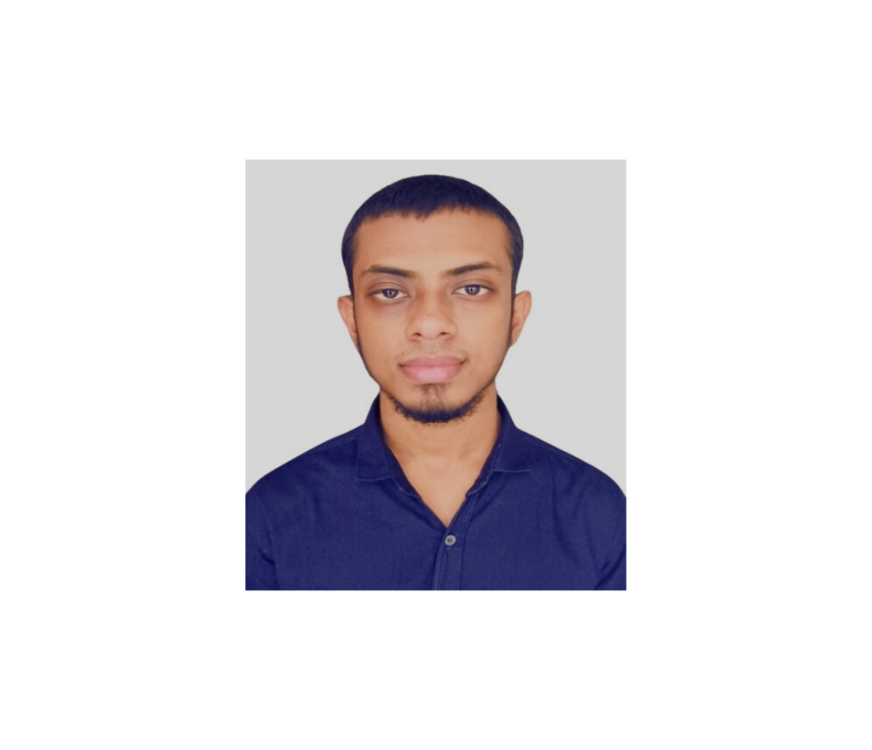


 Education
 Address
I’m someone who will try to do anything approved by my religion, Islam, to reach my goals.
I wanna make my family happy, have a peaceful life and do something to make the world a better place for the generations to come. Being peaceful, humble and respectful to others has led me to being the person I am today.
I wanna continue on striving for greatness.

2024-2028 | Major in IT
Bangladesh Army University of Science and Technology (BAUET)

2021-2023 | Higher Secondary
Armed Police Battalion Public School and College

2019-2021 | Secondary
Derahar Government High-School

Permanent: Nandigram, Bogura

Present: Quadirabad Cantonment, Natore
 About me




Skills
- Basic coding with C and C++
- Basic webpage development with HTML
- Ability to work for hours with same motivation
- Good control over MS office programs (MS Word, MS Excel, MS Powerpoint)


@gettinggood325


+880 1873-019661
shababrahman47@gmail.com

Hobbies
Contact
BSc in CSE
Shabab Rahman

